**Проектирование базы данных и разработка**

**объектов базы данных.**

Выполнил:

Студент группы 4ИСИП-321

Гончаров Дмитрий Валентинович

Техническое задание

На основе задания необходимо спроектировать ER-диаграмму для

учета заявок на ремонт оборудования. Обязательна 3 нормальная форма с

обеспечением ссылочной целостности. При разработке диаграммы обратите

внимание на согласованную осмысленную схему именования, создайте

необходимые первичные и внешние ключи. ER-диаграмма должна быть

представлена в формате удобном для просмотра и содержать таблицы, связи

между ними, атрибуты и ключи (типами данных на данном этапе можно

пренебречь).

Получить ER-диаграмму средствами СУБД или средствами

графического редактора для создания диаграмм.

Создайте базу данных, используя предпочтительную платформу, на

сервере баз данных, которую Вам предоставили. Создайте таблицы

основных сущностей, атрибуты, отношения и необходимые ограничения.

Выполните названия таблиц и полей в едином стиле, согласно

отраслевой документации.

Заполните таблицы базы данных (по пять записей для каждой

таблицы).

Выполните резервное копирование БД, сохраните полученные

результаты.

Выберите принцип регистрации пользователей в системе учета заявок

на ремонт оборудования в соответствии с функциональными

обязанностями.

На рисунке 1 представлена ER-диаграмма разработанной базы данных.

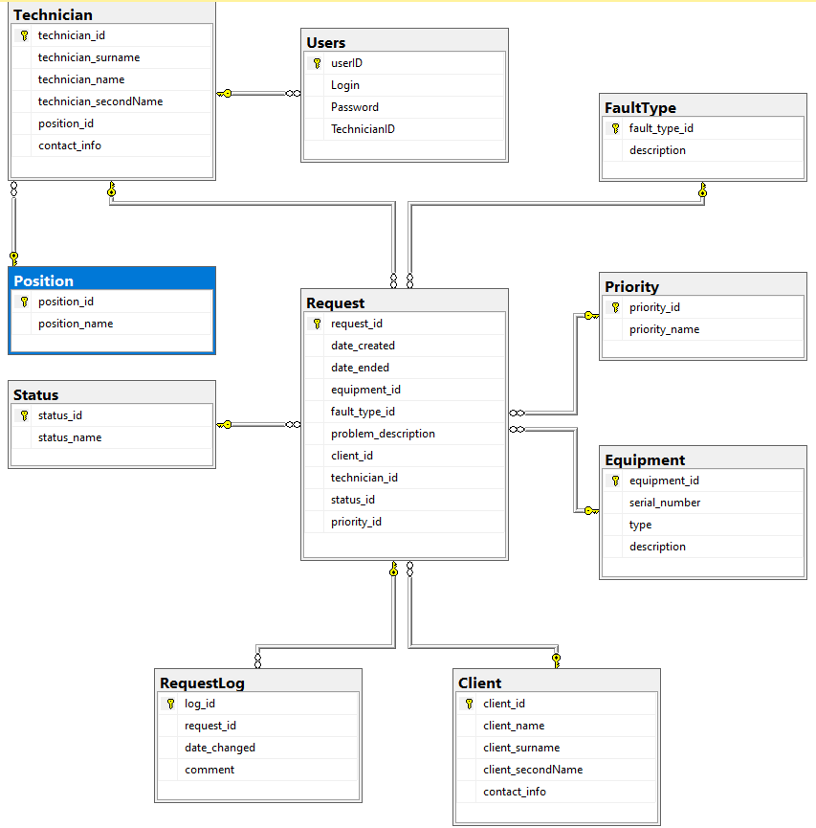

Рисунок 1 – ER диаграмма

На рисунках 2-11 представлено наполнение таблиц БД.

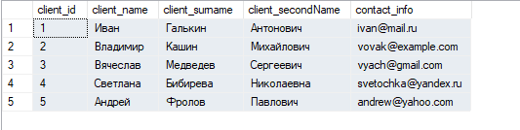

Рисунок 2 – Таблица Client

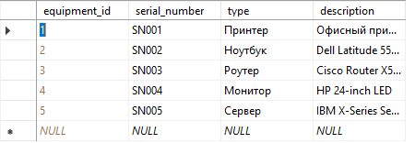

Рисунок 3 – Таблица Equipment

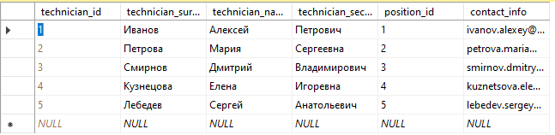

Рисунок 4 – Таблица Technician

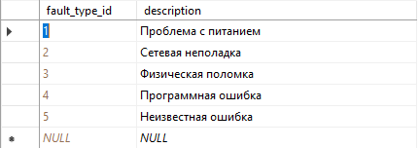

Рисунок 5 – Таблица FaultType

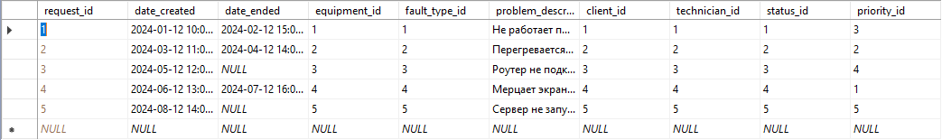

Рисунок 6 – Таблица Requests

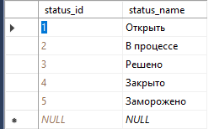

Рисунок 7 – Таблица Status

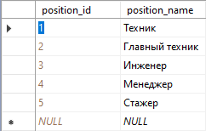

Рисунок 8 – Таблица Position

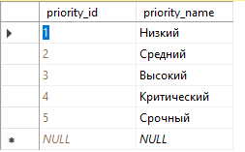

Рисунок 9 – Таблица Priority

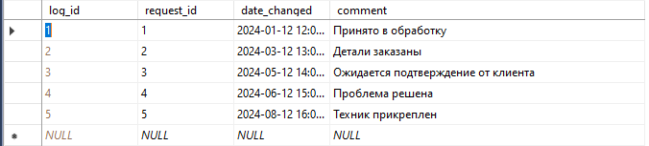

Рисунок 10 – Таблица RequestLog

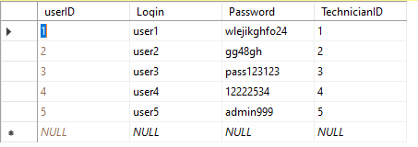

Рисунок 11 – Таблица Users

Скрипт для создания БД отражен в листинге 1.

Листинг 1 – Скрипт для создания БД

|  |
| --- |
| USE [master]  GO  /****** Object: Database [TechnoService] Script Date: 19.12.2024 13:51:05 ******/  CREATE DATABASE [TechnoService]  CONTAINMENT = NONE  ON PRIMARY  ( NAME = N'TechnoService', FILENAME = N'E:\Microsoft SQL Server\MSSQL16.SQLEXPRESS\MSSQL\DATA\TechnoService.mdf' , SIZE = 8192KB , MAXSIZE = UNLIMITED, FILEGROWTH = 65536KB )  LOG ON  ( NAME = N'TechnoService_log', FILENAME = N'E:\Microsoft SQL Server\MSSQL16.SQLEXPRESS\MSSQL\DATA\TechnoService_log.ldf' , SIZE = 8192KB , MAXSIZE = 2048GB , FILEGROWTH = 65536KB )  WITH CATALOG_COLLATION = DATABASE_DEFAULT, LEDGER = OFF  GO  ALTER DATABASE [TechnoService] SET COMPATIBILITY_LEVEL = 160  GO  IF (1 = FULLTEXTSERVICEPROPERTY('IsFullTextInstalled'))  begin  EXEC [TechnoService].[dbo].[sp_fulltext_database] @action = 'enable'  end  GO  ALTER DATABASE [TechnoService] SET ANSI_NULL_DEFAULT OFF  GO  ALTER DATABASE [TechnoService] SET ANSI_NULLS OFF  GO  ALTER DATABASE [TechnoService] SET ANSI_PADDING OFF  GO  ALTER DATABASE [TechnoService] SET ANSI_WARNINGS OFF  GO  ALTER DATABASE [TechnoService] SET ARITHABORT OFF  GO  ALTER DATABASE [TechnoService] SET AUTO_CLOSE OFF  GO  ALTER DATABASE [TechnoService] SET AUTO_SHRINK OFF  GO  ALTER DATABASE [TechnoService] SET AUTO_UPDATE_STATISTICS ON  GO  ALTER DATABASE [TechnoService] SET CURSOR_CLOSE_ON_COMMIT OFF  GO  ALTER DATABASE [TechnoService] SET CURSOR_DEFAULT GLOBAL  GO  ALTER DATABASE [TechnoService] SET CONCAT_NULL_YIELDS_NULL OFF  GO  ALTER DATABASE [TechnoService] SET NUMERIC_ROUNDABORT OFF  GO  ALTER DATABASE [TechnoService] SET QUOTED_IDENTIFIER OFF  GO  ALTER DATABASE [TechnoService] SET RECURSIVE_TRIGGERS OFF  GO  ALTER DATABASE [TechnoService] SET DISABLE_BROKER  GO  ALTER DATABASE [TechnoService] SET AUTO_UPDATE_STATISTICS_ASYNC OFF  GO  ALTER DATABASE [TechnoService] SET DATE_CORRELATION_OPTIMIZATION OFF  GO  ALTER DATABASE [TechnoService] SET TRUSTWORTHY OFF  GO  ALTER DATABASE [TechnoService] SET ALLOW_SNAPSHOT_ISOLATION OFF  GO  ALTER DATABASE [TechnoService] SET PARAMETERIZATION SIMPLE  GO  ALTER DATABASE [TechnoService] SET READ_COMMITTED_SNAPSHOT OFF  GO  ALTER DATABASE [TechnoService] SET HONOR_BROKER_PRIORITY OFF  GO  ALTER DATABASE [TechnoService] SET RECOVERY SIMPLE  GO  ALTER DATABASE [TechnoService] SET MULTI_USER  GO  ALTER DATABASE [TechnoService] SET PAGE_VERIFY CHECKSUM  GO  ALTER DATABASE [TechnoService] SET DB_CHAINING OFF  GO  ALTER DATABASE [TechnoService] SET FILESTREAM( NON_TRANSACTED_ACCESS = OFF )  GO  ALTER DATABASE [TechnoService] SET TARGET_RECOVERY_TIME = 60 SECONDS  GO  ALTER DATABASE [TechnoService] SET DELAYED_DURABILITY = DISABLED  GO  ALTER DATABASE [TechnoService] SET ACCELERATED_DATABASE_RECOVERY = OFF  GO  ALTER DATABASE [TechnoService] SET QUERY_STORE = ON  GO  ALTER DATABASE [TechnoService] SET QUERY_STORE (OPERATION_MODE = READ_WRITE, CLEANUP_POLICY = (STALE_QUERY_THRESHOLD_DAYS = 30), DATA_FLUSH_INTERVAL_SECONDS = 900, INTERVAL_LENGTH_MINUTES = 60, MAX_STORAGE_SIZE_MB = 1000, QUERY_CAPTURE_MODE = AUTO, SIZE_BASED_CLEANUP_MODE = AUTO, MAX_PLANS_PER_QUERY = 200, WAIT_STATS_CAPTURE_MODE = ON)  GO  USE [TechnoService]  GO  /****** Object: Table [dbo].[Client] Script Date: 19.12.2024 13:51:05 ******/  SET ANSI_NULLS ON  GO  SET QUOTED_IDENTIFIER ON  GO  CREATE TABLE [dbo].[Client](  [client_id] [int] IDENTITY(1,1) NOT NULL,  [client_name] [varchar](50) NULL,  [client_surname] [varchar](50) NULL,  [client_secondName] [varchar](50) NULL,  [contact_info] [varchar](100) NULL,  PRIMARY KEY CLUSTERED  (  [client_id] ASC  )WITH (PAD_INDEX = OFF, STATISTICS_NORECOMPUTE = OFF, IGNORE_DUP_KEY = OFF, ALLOW_ROW_LOCKS = ON, ALLOW_PAGE_LOCKS = ON, OPTIMIZE_FOR_SEQUENTIAL_KEY = OFF) ON [PRIMARY]  ) ON [PRIMARY]  GO  /****** Object: Table [dbo].[Equipment] Script Date: 19.12.2024 13:51:05 ******/  SET ANSI_NULLS ON  GO  SET QUOTED_IDENTIFIER ON  GO  CREATE TABLE [dbo].[Equipment](  [equipment_id] [int] IDENTITY(1,1) NOT NULL,  [serial_number] [varchar](50) NULL,  [type] [varchar](50) NULL,  [description] [varchar](255) NULL,  PRIMARY KEY CLUSTERED  (  [equipment_id] ASC  )WITH (PAD_INDEX = OFF, STATISTICS_NORECOMPUTE = OFF, IGNORE_DUP_KEY = OFF, ALLOW_ROW_LOCKS = ON, ALLOW_PAGE_LOCKS = ON, OPTIMIZE_FOR_SEQUENTIAL_KEY = OFF) ON [PRIMARY]  ) ON [PRIMARY]  GO  /****** Object: Table [dbo].[FaultType] Script Date: 19.12.2024 13:51:05 ******/  SET ANSI_NULLS ON  GO  SET QUOTED_IDENTIFIER ON  GO  CREATE TABLE [dbo].[FaultType](  [fault_type_id] [int] IDENTITY(1,1) NOT NULL,  [description] [varchar](255) NULL,  PRIMARY KEY CLUSTERED  (  [fault_type_id] ASC  )WITH (PAD_INDEX = OFF, STATISTICS_NORECOMPUTE = OFF, IGNORE_DUP_KEY = OFF, ALLOW_ROW_LOCKS = ON, ALLOW_PAGE_LOCKS = ON, OPTIMIZE_FOR_SEQUENTIAL_KEY = OFF) ON [PRIMARY]  ) ON [PRIMARY]  GO  /****** Object: Table [dbo].[Position] Script Date: 19.12.2024 13:51:05 ******/  SET ANSI_NULLS ON  GO  SET QUOTED_IDENTIFIER ON  GO  CREATE TABLE [dbo].[Position](  [position_id] [int] IDENTITY(1,1) NOT NULL,  [position_name] [varchar](50) NULL,  PRIMARY KEY CLUSTERED  (  [position_id] ASC  )WITH (PAD_INDEX = OFF, STATISTICS_NORECOMPUTE = OFF, IGNORE_DUP_KEY = OFF, ALLOW_ROW_LOCKS = ON, ALLOW_PAGE_LOCKS = ON, OPTIMIZE_FOR_SEQUENTIAL_KEY = OFF) ON [PRIMARY]  ) ON [PRIMARY]  GO  /****** Object: Table [dbo].[Priority] Script Date: 19.12.2024 13:51:05 ******/  SET ANSI_NULLS ON  GO  SET QUOTED_IDENTIFIER ON  GO  CREATE TABLE [dbo].[Priority](  [priority_id] [int] IDENTITY(1,1) NOT NULL,  [priority_name] [varchar](50) NULL,  PRIMARY KEY CLUSTERED  (  [priority_id] ASC  )WITH (PAD_INDEX = OFF, STATISTICS_NORECOMPUTE = OFF, IGNORE_DUP_KEY = OFF, ALLOW_ROW_LOCKS = ON, ALLOW_PAGE_LOCKS = ON, OPTIMIZE_FOR_SEQUENTIAL_KEY = OFF) ON [PRIMARY]  ) ON [PRIMARY]  GO  /****** Object: Table [dbo].[Request] Script Date: 19.12.2024 13:51:05 ******/  SET ANSI_NULLS ON  GO  SET QUOTED_IDENTIFIER ON  GO  CREATE TABLE [dbo].[Request](  [request_id] [int] IDENTITY(1,1) NOT NULL,  [date_created] [datetime] NULL,  [date_ended] [datetime] NULL,  [equipment_id] [int] NULL,  [fault_type_id] [int] NULL,  [problem_description] [varchar](255) NULL,  [client_id] [int] NULL,  [technician_id] [int] NULL,  [status_id] [int] NULL,  [priority_id] [int] NULL,  PRIMARY KEY CLUSTERED  (  [request_id] ASC  )WITH (PAD_INDEX = OFF, STATISTICS_NORECOMPUTE = OFF, IGNORE_DUP_KEY = OFF, ALLOW_ROW_LOCKS = ON, ALLOW_PAGE_LOCKS = ON, OPTIMIZE_FOR_SEQUENTIAL_KEY = OFF) ON [PRIMARY]  ) ON [PRIMARY]  GO  /****** Object: Table [dbo].[RequestLog] Script Date: 19.12.2024 13:51:05 ******/  SET ANSI_NULLS ON  GO  SET QUOTED_IDENTIFIER ON  GO  CREATE TABLE [dbo].[RequestLog](  [log_id] [int] IDENTITY(1,1) NOT NULL,  [request_id] [int] NULL,  [date_changed] [datetime] NULL,  [comment] [varchar](255) NULL,  PRIMARY KEY CLUSTERED  (  [log_id] ASC  )WITH (PAD_INDEX = OFF, STATISTICS_NORECOMPUTE = OFF, IGNORE_DUP_KEY = OFF, ALLOW_ROW_LOCKS = ON, ALLOW_PAGE_LOCKS = ON, OPTIMIZE_FOR_SEQUENTIAL_KEY = OFF) ON [PRIMARY]  ) ON [PRIMARY]  GO  /****** Object: Table [dbo].[Status] Script Date: 19.12.2024 13:51:05 ******/  SET ANSI_NULLS ON  GO  SET QUOTED_IDENTIFIER ON  GO  CREATE TABLE [dbo].[Status](  [status_id] [int] IDENTITY(1,1) NOT NULL,  [status_name] [varchar](50) NULL,  PRIMARY KEY CLUSTERED  (  [status_id] ASC  )WITH (PAD_INDEX = OFF, STATISTICS_NORECOMPUTE = OFF, IGNORE_DUP_KEY = OFF, ALLOW_ROW_LOCKS = ON, ALLOW_PAGE_LOCKS = ON, OPTIMIZE_FOR_SEQUENTIAL_KEY = OFF) ON [PRIMARY]  ) ON [PRIMARY]  GO  /****** Object: Table [dbo].[Technician] Script Date: 19.12.2024 13:51:05 ******/  SET ANSI_NULLS ON  GO  SET QUOTED_IDENTIFIER ON  GO  CREATE TABLE [dbo].[Technician](  [technician_id] [int] IDENTITY(1,1) NOT NULL,  [technician_surname] [varchar](50) NULL,  [technician_name] [varchar](50) NULL,  [technician_secondName] [varchar](50) NULL,  [position_id] [int] NULL,  [contact_info] [varchar](100) NULL,  PRIMARY KEY CLUSTERED  (  [technician_id] ASC  )WITH (PAD_INDEX = OFF, STATISTICS_NORECOMPUTE = OFF, IGNORE_DUP_KEY = OFF, ALLOW_ROW_LOCKS = ON, ALLOW_PAGE_LOCKS = ON, OPTIMIZE_FOR_SEQUENTIAL_KEY = OFF) ON [PRIMARY]  ) ON [PRIMARY]  GO  /****** Object: Table [dbo].[Users] Script Date: 19.12.2024 13:51:05 ******/  SET ANSI_NULLS ON  GO  SET QUOTED_IDENTIFIER ON  GO  CREATE TABLE [dbo].[Users](  [userID] [int] IDENTITY(1,1) NOT NULL,  [Login] [varchar](50) NULL,  [Password] [varchar](50) NULL,  [TechnicianID] [int] NULL,  PRIMARY KEY CLUSTERED  (  [userID] ASC  )WITH (PAD_INDEX = OFF, STATISTICS_NORECOMPUTE = OFF, IGNORE_DUP_KEY = OFF, ALLOW_ROW_LOCKS = ON, ALLOW_PAGE_LOCKS = ON, OPTIMIZE_FOR_SEQUENTIAL_KEY = OFF) ON [PRIMARY]  ) ON [PRIMARY]  GO  SET IDENTITY_INSERT [dbo].[Client] ON  GO  INSERT [dbo].[Client] ([client_id], [client_name], [client_surname], [client_secondName], [contact_info]) VALUES (1, N'Иван', N'Галькин', N'Антонович', N'ivan@mail.ru')  GO  INSERT [dbo].[Client] ([client_id], [client_name], [client_surname], [client_secondName], [contact_info]) VALUES (2, N'Владимир', N'Кашин', N'Михайлович', N'vovak@example.com')  GO  INSERT [dbo].[Client] ([client_id], [client_name], [client_surname], [client_secondName], [contact_info]) VALUES (3, N'Вячеслав', N'Медведев', N'Сергеевич', N'vyach@gmail.com')  GO  INSERT [dbo].[Client] ([client_id], [client_name], [client_surname], [client_secondName], [contact_info]) VALUES (4, N'Светлана', N'Бибирева', N'Николаевна', N'svetochka@yandex.ru')  GO  INSERT [dbo].[Client] ([client_id], [client_name], [client_surname], [client_secondName], [contact_info]) VALUES (5, N'Андрей', N'Фролов', N'Павлович', N'andrew@yahoo.com')  GO  SET IDENTITY_INSERT [dbo].[Client] OFF  GO  SET IDENTITY_INSERT [dbo].[Equipment] ON  GO  INSERT [dbo].[Equipment] ([equipment_id], [serial_number], [type], [description]) VALUES (1, N'SN001', N'Принтер', N'Офисный принтер DELL 1324')  GO  INSERT [dbo].[Equipment] ([equipment_id], [serial_number], [type], [description]) VALUES (2, N'SN002', N'Ноутбук', N'Dell Latitude 5500')  GO  INSERT [dbo].[Equipment] ([equipment_id], [serial_number], [type], [description]) VALUES (3, N'SN003', N'Роутер', N'Cisco Router X500')  GO  INSERT [dbo].[Equipment] ([equipment_id], [serial_number], [type], [description]) VALUES (4, N'SN004', N'Монитор', N'HP 24-inch LED')  GO  INSERT [dbo].[Equipment] ([equipment_id], [serial_number], [type], [description]) VALUES (5, N'SN005', N'Сервер', N'IBM X-Series Server')  GO  SET IDENTITY_INSERT [dbo].[Equipment] OFF  GO  SET IDENTITY_INSERT [dbo].[FaultType] ON  GO  INSERT [dbo].[FaultType] ([fault_type_id], [description]) VALUES (1, N'Проблема с питанием')  GO  INSERT [dbo].[FaultType] ([fault_type_id], [description]) VALUES (2, N'Сетевая неполадка')  GO  INSERT [dbo].[FaultType] ([fault_type_id], [description]) VALUES (3, N'Физическая поломка')  GO  INSERT [dbo].[FaultType] ([fault_type_id], [description]) VALUES (4, N'Программная ошибка')  GO  INSERT [dbo].[FaultType] ([fault_type_id], [description]) VALUES (5, N'Неизвестная ошибка')  GO  SET IDENTITY_INSERT [dbo].[FaultType] OFF  GO  SET IDENTITY_INSERT [dbo].[Position] ON  GO  INSERT [dbo].[Position] ([position_id], [position_name]) VALUES (1, N'Техник')  GO  INSERT [dbo].[Position] ([position_id], [position_name]) VALUES (2, N'Главный техник')  GO  INSERT [dbo].[Position] ([position_id], [position_name]) VALUES (3, N'Инженер')  GO  INSERT [dbo].[Position] ([position_id], [position_name]) VALUES (4, N'Менеджер')  GO  INSERT [dbo].[Position] ([position_id], [position_name]) VALUES (5, N'Стажер')  GO  SET IDENTITY_INSERT [dbo].[Position] OFF  GO  SET IDENTITY_INSERT [dbo].[Priority] ON  GO  INSERT [dbo].[Priority] ([priority_id], [priority_name]) VALUES (1, N'Низкий')  GO  INSERT [dbo].[Priority] ([priority_id], [priority_name]) VALUES (2, N'Средний')  GO  INSERT [dbo].[Priority] ([priority_id], [priority_name]) VALUES (3, N'Высокий')  GO  INSERT [dbo].[Priority] ([priority_id], [priority_name]) VALUES (4, N'Критический')  GO  INSERT [dbo].[Priority] ([priority_id], [priority_name]) VALUES (5, N'Срочный')  GO  SET IDENTITY_INSERT [dbo].[Priority] OFF  GO  SET IDENTITY_INSERT [dbo].[Request] ON  GO  INSERT [dbo].[Request] ([request_id], [date_created], [date_ended], [equipment_id], [fault_type_id], [problem_description], [client_id], [technician_id], [status_id], [priority_id]) VALUES (1, CAST(N'2024-01-12T10:00:00.000' AS DateTime), CAST(N'2024-02-12T15:00:00.000' AS DateTime), 1, 1, N'Не работает принтер', 1, 1, 1, 3)  GO  INSERT [dbo].[Request] ([request_id], [date_created], [date_ended], [equipment_id], [fault_type_id], [problem_description], [client_id], [technician_id], [status_id], [priority_id]) VALUES (2, CAST(N'2024-03-12T11:00:00.000' AS DateTime), CAST(N'2024-04-12T14:00:00.000' AS DateTime), 2, 2, N'Перегревается ноутбук', 2, 2, 2, 2)  GO  INSERT [dbo].[Request] ([request_id], [date_created], [date_ended], [equipment_id], [fault_type_id], [problem_description], [client_id], [technician_id], [status_id], [priority_id]) VALUES (3, CAST(N'2024-05-12T12:00:00.000' AS DateTime), NULL, 3, 3, N'Роутер не подключается к сети', 3, 3, 3, 4)  GO  INSERT [dbo].[Request] ([request_id], [date_created], [date_ended], [equipment_id], [fault_type_id], [problem_description], [client_id], [technician_id], [status_id], [priority_id]) VALUES (4, CAST(N'2024-06-12T13:00:00.000' AS DateTime), CAST(N'2024-07-12T16:00:00.000' AS DateTime), 4, 4, N'Мерцает экран монитора', 4, 4, 4, 1)  GO  INSERT [dbo].[Request] ([request_id], [date_created], [date_ended], [equipment_id], [fault_type_id], [problem_description], [client_id], [technician_id], [status_id], [priority_id]) VALUES (5, CAST(N'2024-08-12T14:00:00.000' AS DateTime), NULL, 5, 5, N'Сервер не запускается', 5, 5, 5, 5)  GO  SET IDENTITY_INSERT [dbo].[Request] OFF  GO  SET IDENTITY_INSERT [dbo].[RequestLog] ON  GO  INSERT [dbo].[RequestLog] ([log_id], [request_id], [date_changed], [comment]) VALUES (1, 1, CAST(N'2024-01-12T12:00:00.000' AS DateTime), N'Принято в обработку')  GO  INSERT [dbo].[RequestLog] ([log_id], [request_id], [date_changed], [comment]) VALUES (2, 2, CAST(N'2024-03-12T13:00:00.000' AS DateTime), N'Детали заказаны')  GO  INSERT [dbo].[RequestLog] ([log_id], [request_id], [date_changed], [comment]) VALUES (3, 3, CAST(N'2024-05-12T14:00:00.000' AS DateTime), N'Ожидается подтверждение от клиента')  GO  INSERT [dbo].[RequestLog] ([log_id], [request_id], [date_changed], [comment]) VALUES (4, 4, CAST(N'2024-06-12T15:00:00.000' AS DateTime), N'Проблема решена')  GO  INSERT [dbo].[RequestLog] ([log_id], [request_id], [date_changed], [comment]) VALUES (5, 5, CAST(N'2024-08-12T16:00:00.000' AS DateTime), N'Техник прикреплен')  GO  SET IDENTITY_INSERT [dbo].[RequestLog] OFF  GO  SET IDENTITY_INSERT [dbo].[Status] ON  GO  INSERT [dbo].[Status] ([status_id], [status_name]) VALUES (1, N'Открыть')  GO  INSERT [dbo].[Status] ([status_id], [status_name]) VALUES (2, N'В процессе')  GO  INSERT [dbo].[Status] ([status_id], [status_name]) VALUES (3, N'Решено')  GO  INSERT [dbo].[Status] ([status_id], [status_name]) VALUES (4, N'Закрыто')  GO  INSERT [dbo].[Status] ([status_id], [status_name]) VALUES (5, N'Заморожено')  GO  SET IDENTITY_INSERT [dbo].[Status] OFF  GO  SET IDENTITY_INSERT [dbo].[Technician] ON  GO  INSERT [dbo].[Technician] ([technician_id], [technician_surname], [technician_name], [technician_secondName], [position_id], [contact_info]) VALUES (1, N'Иванов', N'Алексей', N'Петрович', 1, N'ivanov.alexey@example.com')  GO  INSERT [dbo].[Technician] ([technician_id], [technician_surname], [technician_name], [technician_secondName], [position_id], [contact_info]) VALUES (2, N'Петрова', N'Мария', N'Сергеевна', 2, N'petrova.maria@example.com')  GO  INSERT [dbo].[Technician] ([technician_id], [technician_surname], [technician_name], [technician_secondName], [position_id], [contact_info]) VALUES (3, N'Смирнов', N'Дмитрий', N'Владимирович', 3, N'smirnov.dmitry@example.com')  GO  INSERT [dbo].[Technician] ([technician_id], [technician_surname], [technician_name], [technician_secondName], [position_id], [contact_info]) VALUES (4, N'Кузнецова', N'Елена', N'Игоревна', 4, N'kuznetsova.elena@example.com')  GO  INSERT [dbo].[Technician] ([technician_id], [technician_surname], [technician_name], [technician_secondName], [position_id], [contact_info]) VALUES (5, N'Лебедев', N'Сергей', N'Анатольевич', 5, N'lebedev.sergey@example.com')  GO  SET IDENTITY_INSERT [dbo].[Technician] OFF  GO  SET IDENTITY_INSERT [dbo].[Users] ON  GO  INSERT [dbo].[Users] ([userID], [Login], [Password], [TechnicianID]) VALUES (1, N'user1', N'wlejikghfo24', 1)  GO  INSERT [dbo].[Users] ([userID], [Login], [Password], [TechnicianID]) VALUES (2, N'user2', N'gg48gh', 2)  GO  INSERT [dbo].[Users] ([userID], [Login], [Password], [TechnicianID]) VALUES (3, N'user3', N'pass123123', 3)  GO  INSERT [dbo].[Users] ([userID], [Login], [Password], [TechnicianID]) VALUES (4, N'user4', N'12222534', 4)  GO  INSERT [dbo].[Users] ([userID], [Login], [Password], [TechnicianID]) VALUES (5, N'user5', N'admin999', 5)  GO  SET IDENTITY_INSERT [dbo].[Users] OFF  GO  ALTER TABLE [dbo].[Request] WITH CHECK ADD FOREIGN KEY([client_id])  REFERENCES [dbo].[Client] ([client_id])  GO  ALTER TABLE [dbo].[Request] WITH CHECK ADD FOREIGN KEY([equipment_id])  REFERENCES [dbo].[Equipment] ([equipment_id])  GO  ALTER TABLE [dbo].[Request] WITH CHECK ADD FOREIGN KEY([fault_type_id])  REFERENCES [dbo].[FaultType] ([fault_type_id])  GO  ALTER TABLE [dbo].[Request] WITH CHECK ADD FOREIGN KEY([priority_id])  REFERENCES [dbo].[Priority] ([priority_id])  GO  ALTER TABLE [dbo].[Request] WITH CHECK ADD FOREIGN KEY([status_id])  REFERENCES [dbo].[Status] ([status_id])  GO  ALTER TABLE [dbo].[Request] WITH CHECK ADD FOREIGN KEY([technician_id])  REFERENCES [dbo].[Technician] ([technician_id])  GO  ALTER TABLE [dbo].[RequestLog] WITH CHECK ADD FOREIGN KEY([request_id])  REFERENCES [dbo].[Request] ([request_id])  GO  ALTER TABLE [dbo].[Technician] WITH CHECK ADD FOREIGN KEY([position_id])  REFERENCES [dbo].[Position] ([position_id])  GO  ALTER TABLE [dbo].[Users] WITH CHECK ADD FOREIGN KEY([TechnicianID])  REFERENCES [dbo].[Technician] ([technician_id])  GO  USE [master]  GO  ALTER DATABASE [TechnoService] SET READ_WRITE  GO |